**Visvesvaraya Technological University**

**Belagavi, Karnataka-590 018**



A Mini Project Report on

**“DEKU PIZZA ASAP”**

Mini Project Report submitted in partial fulfillment of the requirement for the award of the degree

**Bachelor of Engineering in**

**Information Science and Engineering**

Submitted by,

**N Prasanna Kumar**

**1MJ17IS033**

Under the esteemed guidance of

**Dr. Mannar Mannan**

**Associate Professor**

**M V J College of Engineering, Bengaluru-67**

**Department of Information Science and Engineering**

**2019-2020**

**M V J College of Engineering, Bengaluru-67**

**Department of Information Science and Engineering**

**2019-20**



**CERTIFICATE**

Certified that the project work titled **“DEKU PIZZA ASAP”** is a bonafide work carried out by **N PRASANNA KUMAR (1MJ17IS033)** in partial fulfillment for the award of Bachelor of Engineering in Information Science and Engineering of the Visvesvaraya Technological University, Belagavi during the academic year 2019-20. It is certified that all corrections and suggestions indicated for Internal Assessment have been incorporated in the report. The report has been approved as it satisfies the academic requirements in respect of Project Work prescribed for the Bachelor of Engineering Degree.

**Signature of Guide**

**Signature of HOD**

**Dr. Mannar Mannan**

**Mrs. Sanchari Saha**

**Associate Professor**

**HOD**

**Dept. of ISE**

**Dept. of ISE**

**MVJCE**

**MVJCE**

**Sl.no** **Examiners** **Signature with date**

**1**

**2**

**M V J College of Engineering, Bengaluru-67**

**Department of Information Science and Engineering**

**2019-20**



**DECLARATION**

I, N PRASANNA KUMAR (1MJ17IS033) hereby declare that the dissertation entitled, **“DEKU PIZZA ASAP ”** has been completed and written by meunder the supervision of Dr Mannar Mannan, Associate Professor, Department of Information Science and Engineering, MVJCE, Bangalore, in partial fulfillment of the requirements for the award of the degree of Bachelor of Engineering in Information Science and Engineering, of Visvesvaraya Technological University, Belagavi. The dissertation report is original and it has not been submitted for any other degree in any university.

Date:

Place:

N PRASANNA KUMAR

(1MJ17IS033)

**ACKNOWLEDGEMENT**

The satisfaction that accompanies the successful completion of this project report would be incomplete without the mention of people who made it possible, without whose constant guidance and encouragement, would have made efforts go in vain. I consider ourselves privileged to express gratitude and respect towards all those who guided us through the completion of this project.

I, acknowledge our beloved Principal **Dr. Nagaraj Sitaram**, who has always been and shall always be a source of motivation to us.

I am grateful to **Mrs. Sanchari Saha**, HOD, Information Science and Engineering, for giving the support and encouragement that was necessary for the completion of this project. In this context, I would also like to thank all the other staff members, both teaching and non-teaching, who have extended their timely help and eased our task.

I, also convey thanks to my project guide **Dr. Mannar Mannan**, Associate Professor, Department of Information Science and Engineering, for providing encouragement, constant support and guidance which was of great help to complete this project work successfully.

I would like to express my heart-felt gratitude to my parents and friends for their continued moral and material support throughout the course and in helping me finalize the project report.

N PRASANNA KUMAR

**ABSTRACT**

Increased demand of restaurant-goers generated the need for much attention for the hospitality industry. Providing much option with ease of ordering and delivering is the need of the hours. Technological interference has become mandatory to improve the quality of the service and business in this industry. Evidences are already existed for partial automation of food ordering process in the country; most of these technologies implemented are based on wireless technologies . This manuscript reports implementation and integration of web based technology for restaurants. A dynamic database utility system was designed to fetch all the information from a centralised database. User utility was given importance during the development of this interface and efficiency, accuracy was the priority for better results and services and to reduce the majority of the human error. It was observed that this system was successful in overcoming the shortcomings found in the previously developed similar systems. Moreover, this system was very cost effective in development as well as during use.

The online pizza ordering system set up menu online and the customers easily places the order with a simple mouse click. Also with a menu online you can easily track the orders, maintain customer's database and improve your food delivery. This system allows the user to select the desired Varity pizza items from the displayed menu. The user orders the pizza , sodas, calzone items. The payment can be made online system. The user’s details are maintained confidential because it maintains a separate account for each user. An id and password is provided for each user. Therefore it provides a more secured ordering.

**CONTENTS**

**CHAPTERS PAGE NO'S**

**Chapter 1 Introduction 01**

**Chapter 2 System Requirement 09**

2.1 Hardware Requirements

2.2 Software Requirements

**Chapter 3 Problem Description 11**

**Chapter 4 System Design 16**

4.1 ER Diagram

4.2 Schema Diagram

**Chapter 5 Implementation 17**

5.1 Introduction to software used

5.2 Source code

5.3 SQL Stored procedure

5.4 SQL Triggers

**Chapter 6 Screenshots 23**

**Chapter 7 Conclusion and Future 28**

**References 31**

**LIST OF FIGURES**

**Fig Number Fig Name Chapter No Page No**

4.1 ER Diagram 4 16

4.2 Schema Diagram 4 17

6.1 user login page 6 25

6.2 notification 6 25

6.3 account information 6 25

6.4 billing information 6 26

6.5 contact information 6 26

6.6 menu 6 28

6.7 Staff login 6 28

6.8 admin account information 6 29

6.9 new user registration 6 30

**Chapter 1**

**INTRODUCTION**

                                           Abstract

You must have ordered your pizzas on phone for home delivery. The process seems easy to use but at times there is miscommunication. As there is no visual menu shown during a phone call, the employees have to repeat a lot of things again and again to the customers. It’s a time consuming process which at times irritates customers. Also it takes a lot of time of the pizzeria staff.

It would be much more comfortable for the customers to have an online pizza ordering system. It would be hassle free for users as they can select the pizzas they want and make payment for it. Also it will reduce the purchasing time for customers. Let us look at another benefit of using this system. Suppose I go to a pizzeria and make order. Even after ordering pizzas from their outlet, I have to wait at least 15 minutes for my order to be ready. Wouldn’t it be much more convenient if I ordered my pizzas before using a mobile app or an online system and then it will tell me the time by which I have to pick my order from their counter. It would be great for me as I don’t need to wait for my pizza.

I need to reach there only when my pizza is ready. In a nutshell, we can say that improved and efficient services are provided to the customers by the inclusion of internet in your business. As a business point of view it gives you an edge over your competitors.

##### **Advantages**

* It overcomes all the problems of existing system.
* Pizza can be order in more convenient way.
* Payment can be easily done using various online mode or cash on delivery (COD).
* It makes system very effective for ordering a pizza.
* Admin can view sales report which can be helpful for decision making.
* Easy add/update/delete process of pizza.

##### **Disadvantages**

* It requires a reliable internet connection.
* System may provide inaccurate results if data not entered correctly.
* Not friendly interface

**Chapter 2**

**Software Requirement specification**

**SOFTWARE**

A software requirements specification (SRS) is a description of a software system to be developed. It lays out functional and non-functional requirements, and may include a set of use cases that describe user interactions that the software must provide.

Characteristics of good SRS:

⦁ Complete.

⦁ Consistent.

⦁ Feasible.

⦁ Modifiable.

⦁ Unambiguous.

⦁ Testable.

⦁ Requirements

⦁ Software Requirements:

Operating System      - Windows / MacOS

User Interface                  - HTML, CSS

Programming Language      - PHP

Database                  - MYSQL

**Software Features:**

**⦁ PHP**

PHP is a scripting language originally designed for producing dynamic web pages. It has evolved to include a command line interface capability and can be used in standalone graphical applications. While PHP was originally created by Rasmus Lerdorf in 1995, the main

implementation of PHP is now produced by The PHP Group and serves as the de facto standard for PHP as there is no formal specification.

⦁ **CSS**

Cascading Style Sheets (CSS) is a style sheet language used for describing the presentation of a document written in a mark-up language. Although most often used to set the visual style of web pages and user interfaces written in HTML and XHTML, the language can be applied to any XML document, including plain XML, SVG and XUL, and is applicable to rendering in speech, or on other media. Along with HTML and JavaScript, CSS is a cornerstone technology used by most websites to create visually engaging webpages, user interfaces for web applications, and user interfaces for many mobile applications.

CSS is designed primarily to enable the separation of presentation and content, including aspects such as the layout, colors, and fonts. This separation can improve content accessibility, provide more flexibility and control in the specification of presentation characteristics, enable multiple HTML pages to share formatting by specifying the relevant CSS in a separate .css file, and reduce complexity and repetition in the structural content.

⦁ Hardware Requirements:

⦁ Processor : INTEL core i3

⦁ MEMORY : 8 GB

⦁ RAM : 2 GB

⦁ HDD : free space of 50 GB

**Chapter 3**

**Problem Description**

                PROBLEM DESCRIPTION

**Existing System:**

In existing system for giving any orders users should visit hotels or restaurants to know about food items and them give order and pay advance.  In this method time and manual work is required. Maintaining critical information in the files and manuals is full of risk and a tedious process.

**Proposed System:**

This online application enables the end users to register online, select the food from the e-menu card, read the E-menu card and order food online. By just selecting the food that the user want to have. The results after selecting the food from the E-menu card will directly appear in the screen near the Chef who is going to cook the food for you. By using this application the work of the Waiter is reduced and we can also say that the work is nullified. The benefit of this is that if there is rush in the Restaurant then there will be chances that the waiters will be unavailable and the users can directly order the food to the chef online by using this application. The user will be given a username and a password to login.

          Deku web pizza is ordering pizza asap without any delay to get the fastest and the best pizza

In mvjce

The database has the following tables for maintaining the details,

⦁ admin

⦁          admin_notification

⦁ calzone

⦁ carts

⦁ category

⦁ classic

⦁ notificationlogs

⦁ menu

⦁          Orders

⦁         Payment

⦁ Sodas

⦁          Special

⦁         users

The description of the tables are as follows,

**Table 3.0- ALL TABLES**

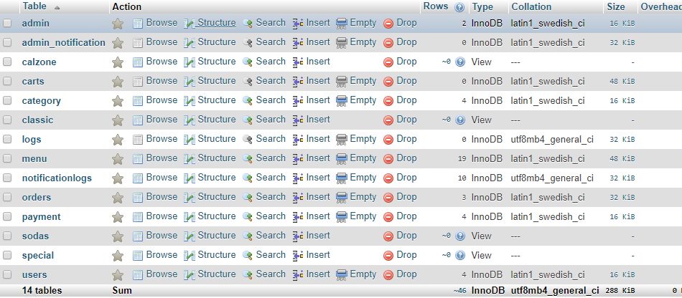

**Table 3.1- ADMIN**

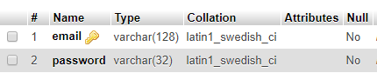

**Table 3.2- admin_notification**

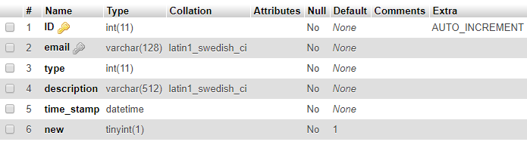

**Table 3.3- carts** 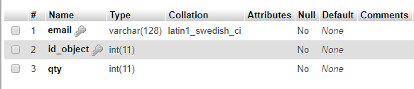

    **Table 3.4- categories** 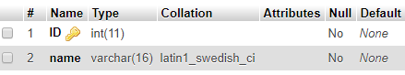

**Table 3.5- LOGS**

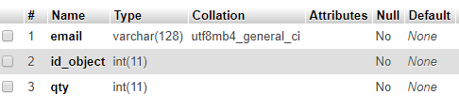

**Table 3.6- menu**

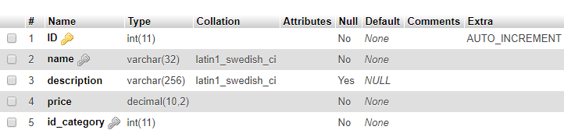

**Table 3.7-notificationlogs**

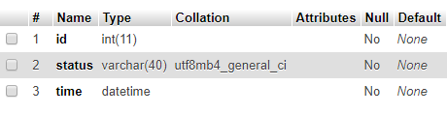

**Table 3.8-orders** 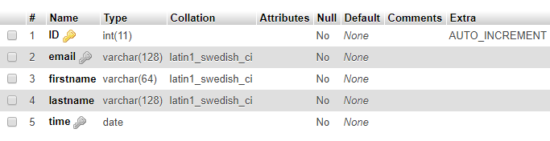

**Table 3.9-payment**

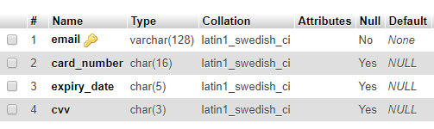

**Table 3.10-users** 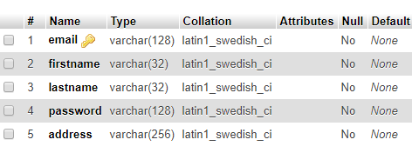

**VIEWS**

**Table 3.8- CALZONE**

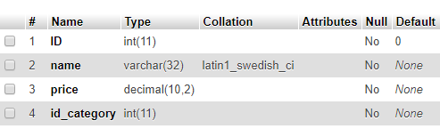

**Table 3.9- CLASSIC**

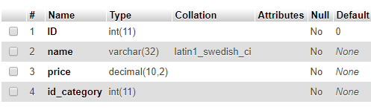

**Table 3.10- SODAS**

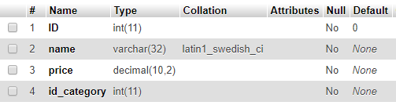

**Table 3.11- SPECIAL**

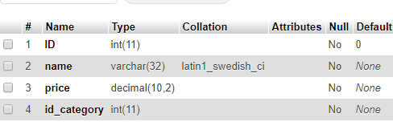

**Table 3.12- Triggers**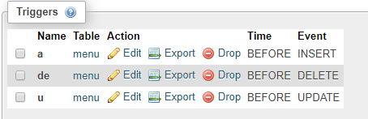

**Chapter 4**

**ER Diagram**

**4.1-ER Relation**

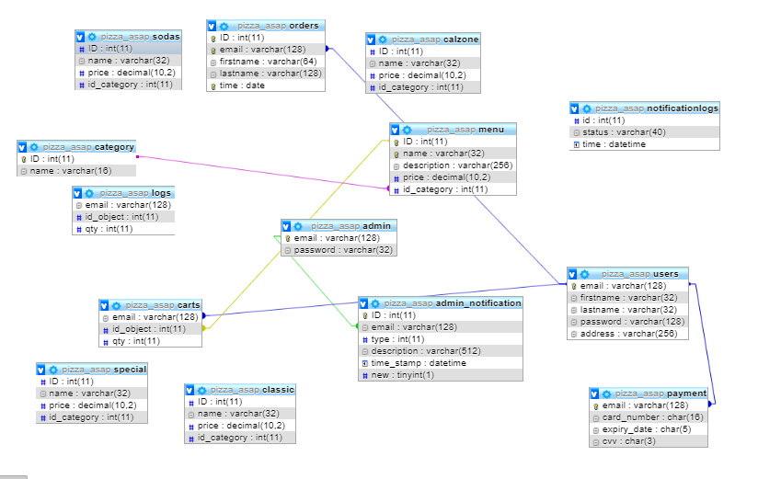

**4.2-ER Diagram**

An Entity Relationship Diagram is a data modelling technique that graphically illustrates an information system entity and the relationship.

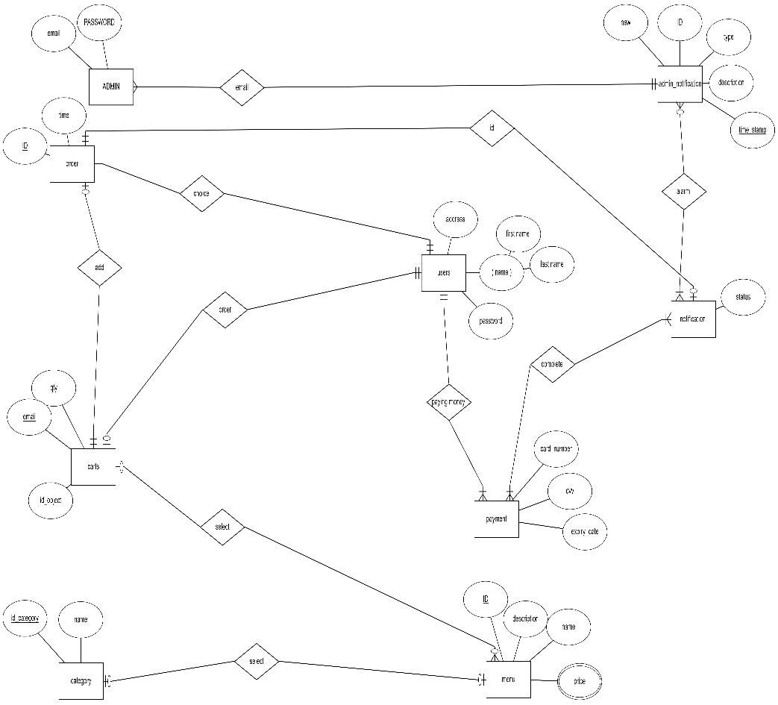

**Chapter 5**

**Source code**

**5.Source code**

**Index.php**

**<?php**

**require_once '../php_utils/db_connection.php';**

**if(session_status() == PHP_SESSION_NONE) {**

**session_start();**

**}**

**if(isset($_POST["email"])) {**

**$conn = connect();**

**$user_stmt = $conn->prepare("select email, password from users where email=?");**

**$user_email = $_POST["email"];**

**$user_stmt->bind_param("s", $user_email);**

**$user_stmt->execute();**

**$user_stmt->bind_result($r_email, $r_password);**

**$user_stmt->store_result();**

**$user_stmt->fetch()**

**if($user_stmt->num_rows > 0) {**

**if(strcmp($_POST["password"], $r_password) === 0) {**

**$_SESSION['user'] = $user_email;**

**header("location: home.php");**

**$user_stmt->close();**

**$conn->close();**

**die();**

**}**

**else**

**{**

**?><script type="text/javascript">**

**alert("Unknown e-mail or password");**

**</script>**

**<?php**

**}**

**}**

**else {**

**?><script type="text/javascript">**

**alert("Unknown e-mail or password");**

**</script>**

**<?php**

**$user_stmt->close();**

**$conn->close();**

**}**

**}**

**?>**

**Db_connection.php**

**<?php**

**function error_found()**

**{**

**header("Location: ../error/error.html");**

**}**

**function connect() {**

**$servername = "localhost";**

**$username = "root";**

**$password = "";**

**$database = "pizza_asap";**

**//Connecting to the database**

**$conn = new mysqli($servername, $username, $password, $database);**

**date_default_timezone_set("Asia/Calcutta");**

**//Check for connection errors**

**if($conn->connect_errno)**

**{**

**echo "Connection to MySQL database failed: [" .$conn->connect_errno. "] - " .$conn->connect_error;**

**}**

**set_error_handler('error_found');**

**return $conn;**

**}**

**?>**

**MENU.php**

**<?php**

**class pizza {**

**public $ID;**

**public $name;**

**public $description;**

**public $price;**

**public $id_category;**

**}**

**?>**

**notifications.php**

**<?php**

**$conn =mysqli_connect("localhost","root","","pizza_asap");**

**if($conn-> connect_error){**

**die("connection failed:".$conn -> connect_error);**

**}**

**$sql="select  email,description,time_stamp from admin_notification";**

**$result= $conn-> query($sql);**

**?>**

**<!DOCTYPE html>**

**<html lang="en">**

**<head>**

**<meta charset="utf-8">**

**<meta name="author" content="PS">**

**<meta name="viewport" content="width=device-width,initial-scale=1">**

**<meta name="description" content="Online Pizza Delivery">**

**<meta name="keywords" content="online,pizza,pasta">**

**<link rel="icon" href="../favicon.ico" type="image/x-icon">**

**<link rel="stylesheet" href="https://maxcdn.bootstrapcdn.com/bootstrap/4.1.3/css/bootstrap.min.css">**

**<script src="https://ajax.googleapis.com/ajax/libs/jquery/3.3.1/jquery.min.js"></script>**

**<script src="https://cdnjs.cloudflare.com/ajax/libs/popper.js/1.14.3/umd/popper.min.js"></script>**

**<script src="https://maxcdn.bootstrapcdn.com/bootstrap/4.1.3/js/bootstrap.min.js"></script>**

**<link rel="stylesheet" type="text/css" href="../styles/customBgJumbo.css">**

**<link rel="stylesheet" type="text/css" href="../styles/home.css">**

**<link rel="stylesheet" href="https://use.fontawesome.com/releases/v5.1.0/css/all.css" integrity="sha384-lKuwvrZot6UHsBSfcMvOkWwlCMgc0TaWr+30HWe3a4ltaBwTZhyTEggF5tJv8tbt" crossorigin="anonymous">**

**<script src="../scripts/smoothScrolling.js"></script>**

**<link rel="stylesheet" type="text/css" href="../styles/account.css">**

**<link rel="stylesheet" type="text/css" href="../styles/notifications.css">**

**<!--<script src="../scripts/notifications.js"></script> -->**

**<title>Notifications</title>**

**</head>**

**<body>**

**<nav class="navbar navbar-expand-md navbar-dark bg-dark fixed-top">**

**<a href="#top" class="navbar-brand">Pizza ASAP!</a>**

**<button class="navbar-toggler" type="button" data-toggle="collapse" data-target="#navbarCollapse">**

**<span class="navbar-toggler-icon"></span>**

**</button>**

**<div class="navbar-collapse collapse justify-content-stretch" id="navbarCollapse">**

**<ul class="navbar-nav ml-auto">**

**<li class="nav-item">**

**<a class="nav-link" href="adminWelcome.php">Home  <span class="fas fa-home"></span></a>**

**</li>**

**<li>**

**<a class="nav-link" href="settings.php">Settings  <span class="fas fa-wrench"></span></a>**

**</li>**

**<li class="nav-item">**

**<input type="hidden" id="mail-field" value="<?= $_SESSION["admin"]?>">**

**<input type="hidden" id="is-admin" value="true">**

**<a class="nav-link active" href="#top">Notifications  <span class="fas fa-bell" id="bell-icon"></span><span class="hidden badge badge-pill badge-danger" id="bell-count">0</span></a>**

**</li>**

**<li class="nav-item">**

**<a class="nav-link" href="../php_utils/logout.php">Logout  <span class="fas fa-sign-out-alt"></span></a>**

**</li>**

**</ul>**

**</div>**

**</nav>**

**<div id="wrapper">**

**<div id="header">**

**<div class="bg">**

**<div class="jumbotron jumbotron-fluid">**

**<h1 >Notifications</h1>**

**</div>**

**</div>**

**</div>**

**<div class="content container">**

**<div class="container-fluid bg-grey rounded">**

**<form action= "notifications.php" method= "post">**

**<h2>Notifications</h2>**

**<hr class="mb-4">**

**<div class="notifications-container">**

**<table style="width:100%" border="1">**

**<tr>**

**<th>email</th>**

**<th>description</th>**

**<th>time_stamp</th></tr>**

**<?php**

**if($result-> num_rows >0)**

**{while($row =$result-> fetch_assoc()){**

**echo "<tr><td>". $row["email"]."</td> <td>".$row["description"]."</td><td>".$row["time_stamp"]."</td></tr>";**

**}**

**echo"</table>";**

**}**

**else { echo "0 result";**

**}**

**$conn -> close();**

**?>**

**</table>**

**<div class= "row text-center">**

**<div class= "col-md-12 align-self-center">**

**<a href="logs.php" input type= "submit" class= "btn btn-danger"> detail</a>**

                             <a href="delete.php"

**input type= "submit" class= "btn btn-danger"> Clear All Notifications</a>**

**head>**

**<body>**

**<nav class="navbar navbar-expand-md navbar-dark bg-dark fixed-top">**

**<a href="#top" class="navbar-brand">Pizza ASAP!</a>**

**<button class="navbar-toggler" type="button" data-toggle="collapse" data-target="#navbarCollapse">**

**<span class="navbar-toggler-icon"></span>**

**</button>**

**<div class="navbar-collapse collapse justify-content-stretch" id="navbarCollapse">**

**<ul class="navbar-nav ml-auto">**

**<li class="nav-item">**

**<a class="nav-link" href="adminWelcome.php">Home  <span class="fas fa-home"></span></a>**

**</li>**

**<li>**

**<a class="nav-link" href="settings.php">Settings  <span class="fas fa-wrench"></span></a>**

**</li>**

**<li class="nav-item">**

**<input type="hidden" id="mail-field" value="<?= $_SESSION["admin"]?>">**

**<input type="hidden" id="is-admin" value="true">**

**<a class="nav-link active" href="#top">Notifications  <span class="fas fa-bell" id="bell-icon"></span><span class="hidden badge badge-pill badge-danger" id="bell-count">0</span></a>**

**</li>**

**<li class="nav-item">**

**<a class="nav-link" href="../php_utils/logout.php">Logout  <span class="fas fa-sign-out-alt"></span></a>**

**</li>**

**</ul>**

**</div>**

**</nav>**

**<div id="wrapper">**

**<div id="header">**

**<div class="bg">**

**<div class="jumbotron jumbotron-fluid">**

**<h1 >Notifications</h1>**

**</div>**

**</div>**

**</div>**

**<div class="content container">**

**<div class="container-fluid bg-grey rounded">**

**<form action= "notifications.php" method= "post">**

**<h2>Notifications</h2>**

**<hr class="mb-4">**

**<div class="notifications-container">**

**<table style="width:100%" border="1">**

**<tr>**

**<th>email</th>**

**<th>description</th>**

**<th>time_stamp</th></tr>**

**<?php**

**if($result-> num_rows >0)**

**{while($row =$result-> fetch_assoc()){**

**echo "<tr><td>".**

**</div>**

**</div>**

**</div>**

**<input type= "hidden" id= "cancel" value= "cancel" name= "cancel">**

**</form>**

**</div>**

**</div>**

**<div id="footer">**

**<footer class="container-fluid text-center">**

**<div class="row align-item-center footer-row">**

**<div class="col-md-12 align-self-center">**

**<a href="#top" title="To Top">**

**<span class="fas fa-chevron-up" style="color:white"></span>**

**</a>**

**</div>**

**</div>**

**<div class="row align-item-center">**

**<div class="col-md-12 align-self-center">**

**<p class="copyright">**

**lastbench@gmail.com**

**</p>**

**</div>**

**</div>**

**</footer>**

**</div>**

**</div>**

**</body>**

**</html>**

**5.3 SQL Stored Procedure**

DELIMITER $$

CREATE DEFINER=`root`@`localhost` PROCEDURE `getmenu`(IN `aid` INT)

SELECT * from menu where id= aid$$

DELIMITER ;

**5.3 SQL Trigger**

**Adding ;**

CREATE TRIGGER `a` BEFORE INSERT ON `menu`

FOR EACH ROW INSERT into notificationlogs values(new.id,"inserted",now())

**Update :**

CREATE TRIGGER `u` BEFORE UPDATE ON `menu`

FOR EACH ROW INSERT into notificationlogs values(new.id,"updated",now())

**Delete :**

CREATE TRIGGER `u` BEFORE UPDATE ON `menu`

FOR EACH ROW INSERT into notificationlogs values(new.id,"updated",now())

**Chapter 6**

**SCREENSHOTS**

Figure 6.1 – user login page

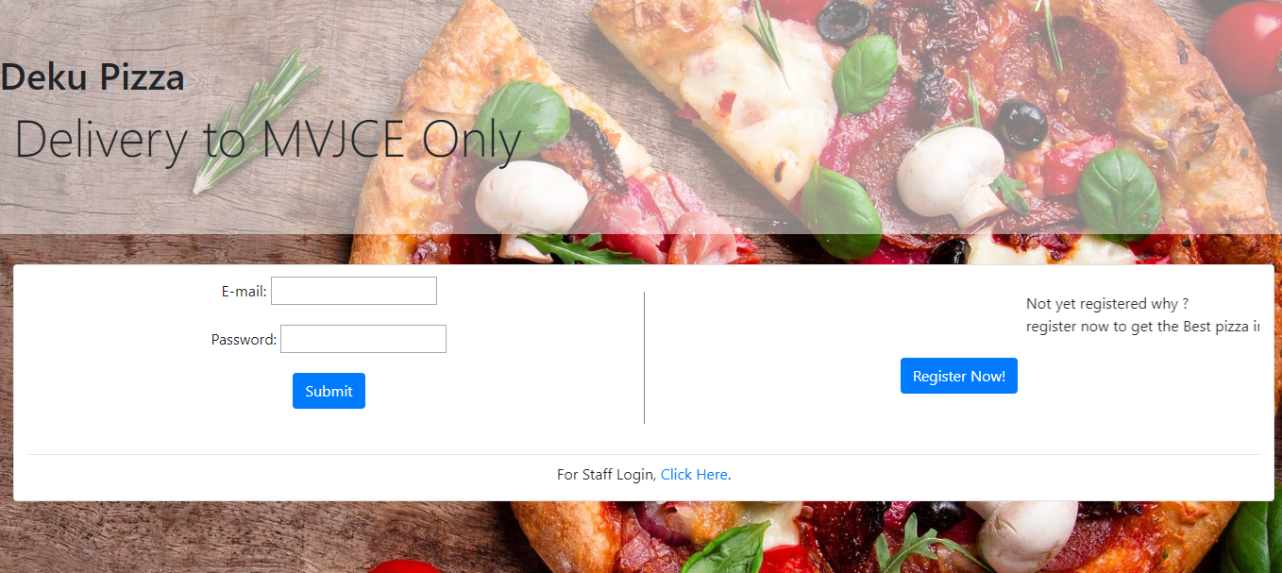Figure 6.2 – notification

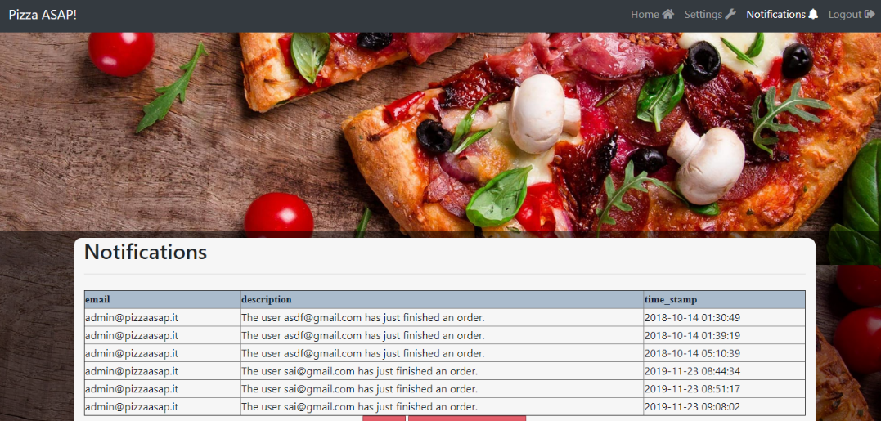

Figure 6.3 – account information

**–––––**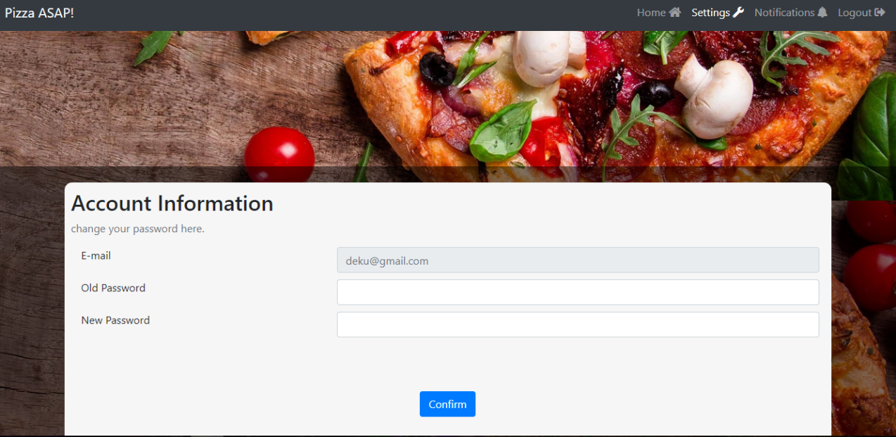

Figure 6.4 – Admin add pizza

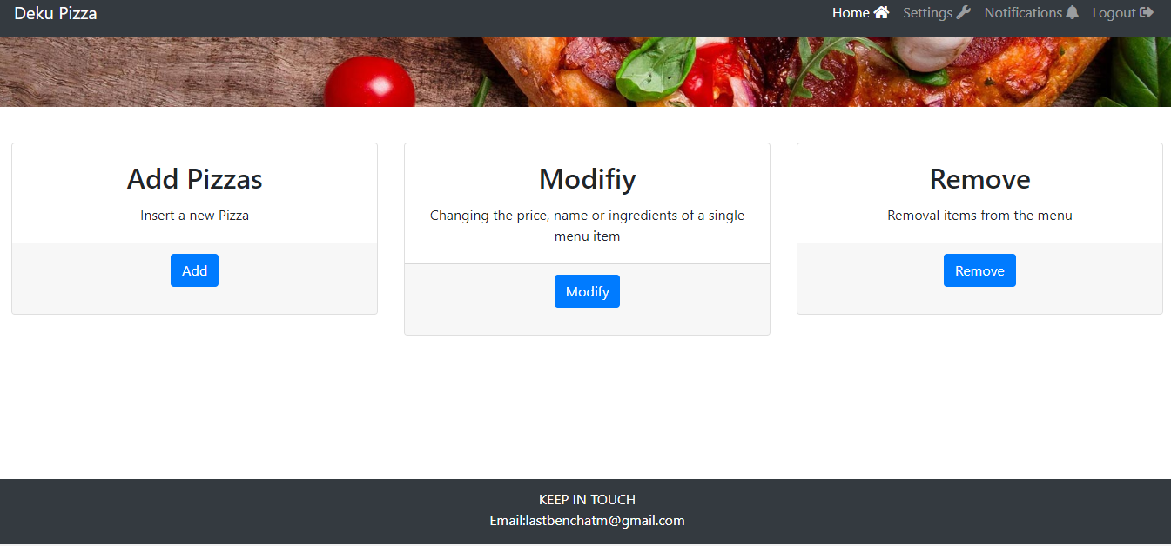

Figure 6.5 – billing information

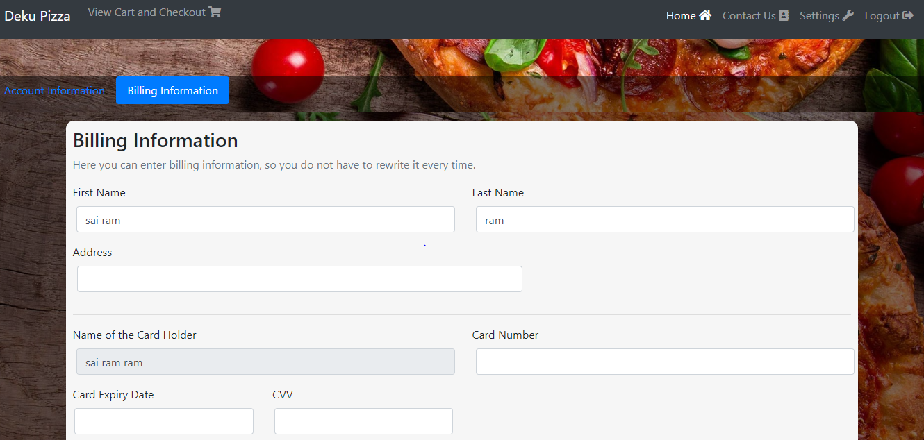 Figure 6.6– contact information

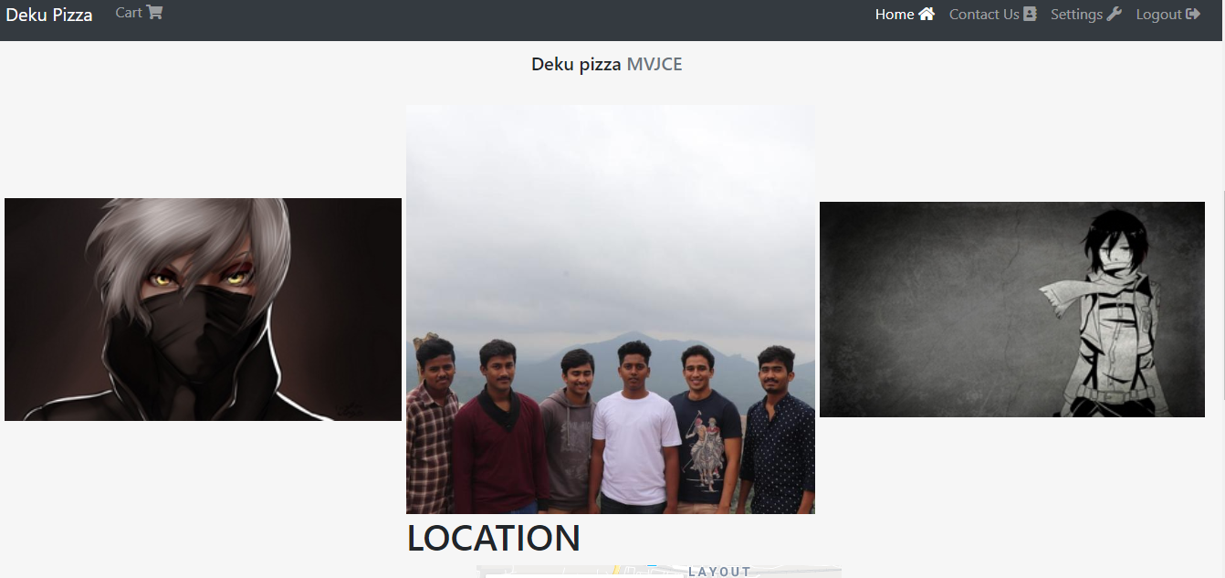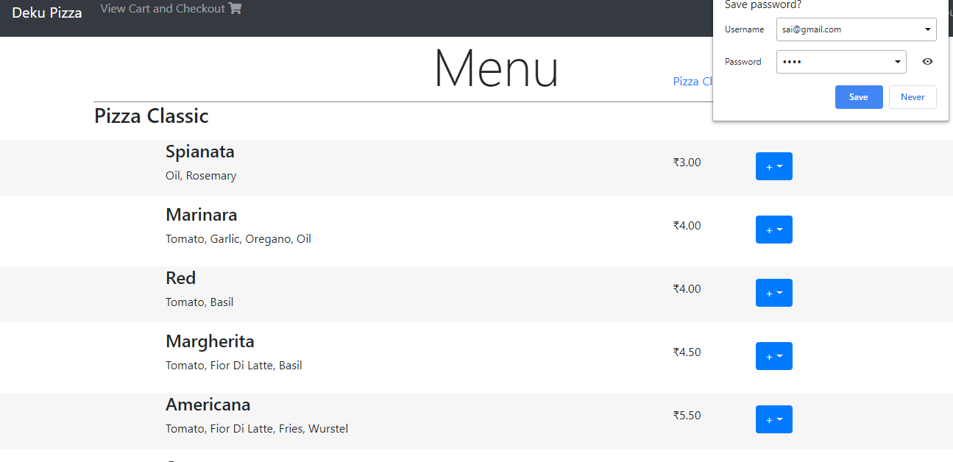 Figure 6.7– menu

Figure 6.8– Staff login

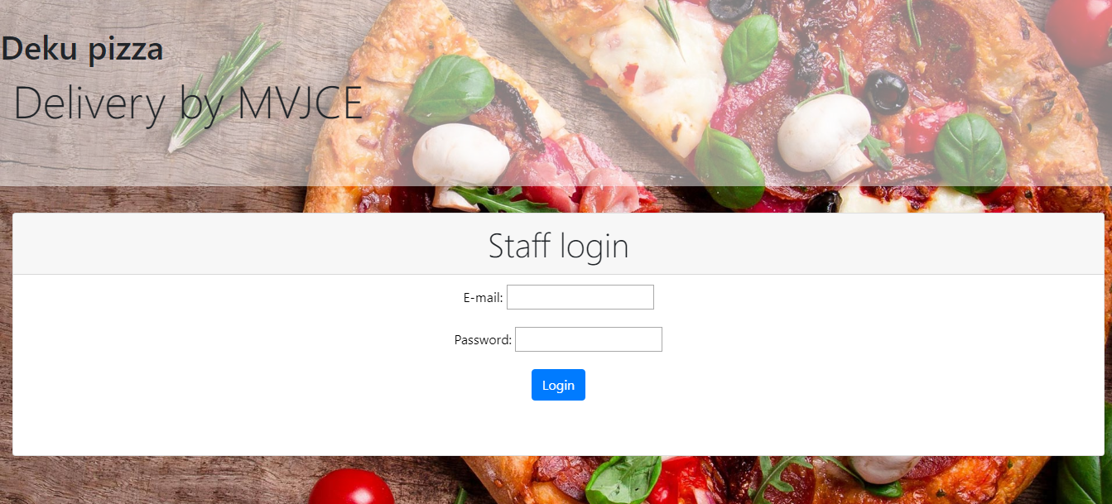

Figure 6.9– admin account information 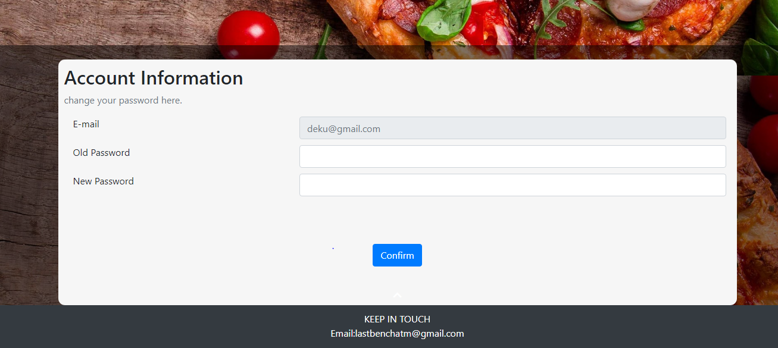

Figure 6.10– new user registration 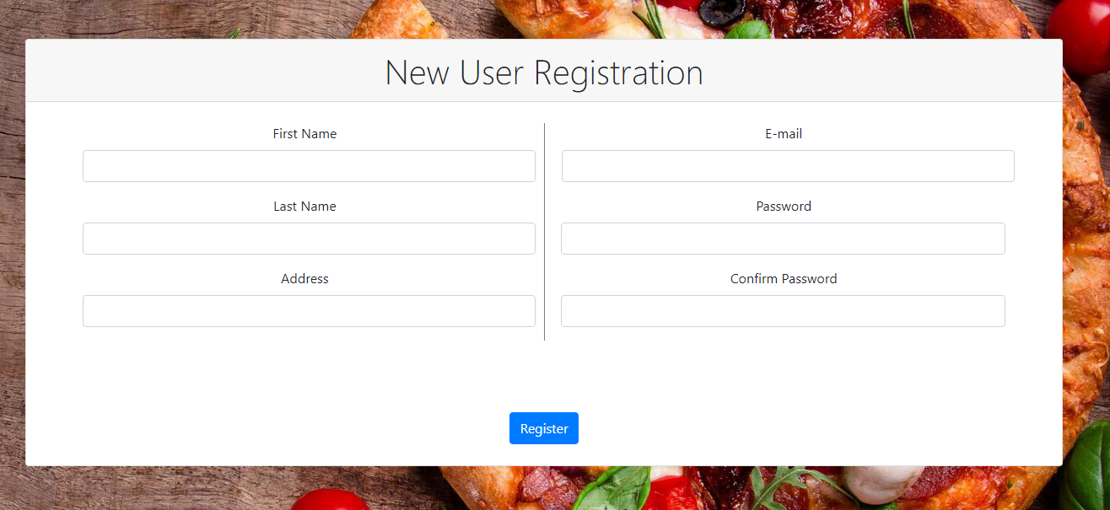

**Chapter 7**

**CONCLUSION AND FUTURE SCOPE**

**Conclusion**

project is only a humble venture to satisfy the needs to manage their project work. Several user-friendly coding has also adopted. This package proves to be a powerful package in satisfying all the requirements of the school. The objective of software planning is to provide a frame work that enables the manager to make reasonable estimates made with a limited time frame at the beginning of the software project and should be updated regularly as the project progresses.

* A description of the background and context of the project and its relation to work already done in the area.
* Made statement of the aims and objectives of the project.
* The description of purpose, scope and applicability.
* We include features and operation in detail, including screen layouts.
* We designed user interface and security issues related to system
* Make it more user friendly .
* More offers with more interactive website will attract more customers.

**Future**

* We can add printer in future.
* We can give more advance software for pizza ordering portal including more facilities
* We will host the platform on online servers to make it accessible worldwide.
* Integrate multiple load balancers to distribute the loads of the system.
* provide more pictures so that the user can get an idea on how the order looks

**REFERENCES**

* [**http://www.google.com**](http://www.google.com)
* [**http://www.w3school.com**](http://www.w3school.com)
* [**http://www.youtube.com**](http://www.youtube.com)
* [**http://www.geeksforgeeks.com**](http://www.geeksforgeeks.com)